Study of photocatalytic degradation of Ibuprofen in water through nanostructures of Co-doped ZnO

Estudo da degradação fotocatalítica de ibuprofeno em água através de nanoestruturas de ZnO dopadas com Co

A. S. Soares¹, Francisca P. Araújo³, Y. Guerra², R. Peña-Garcia³

¹Universidade Federal do Piauí, Pós-Graduação em Ciência e Engenharia dos Materiais, Teresina, PI, Brazil, CEP: 64048-901
²Universidade Federal do Piauí, departamento de Física, Teresina, PI, Brazil
³Universidade Federal Rural de Pernambuco, Unidade Acadêmica do Cabo de Santo Agostinho, PE, Brazil
e-mail: adrianoss@ufpi.edu.br

Abstract: The present work aims to study the impact of pH on the optical and photocatalytic properties of ZnO nanoparticles doped with Co. Specifically ZnO samples doped with 5% Co synthesized by precipitation method, varying pH (7 and 13). Fourier transform infrared analysis revealed functional groups confirming the ZnO hexagonal structure for all the samples. Defects such as zinc vacancies, interstitial zinc, single ionized oxygen vacancy and doubly ionized oxygen vacancy were identified from to PL analyses. These defects may have contributed to decrease of the gap energy. The rate of IBP degradation was 19.3%, 21.0% and 28.4% for the UV-irradiated systems with ZC5-7 and ZC5-13, respectively. However, the photocatalytic response was incremented under optimized conditions using H₂O₂.
Keywords: Degradation of ibuprofen, Co doped ZnO nanoparticles, PL, photocatalytic performance, Structural defects.

Introduction
Zinc oxide (ZnO) is a group II-VI semiconductor material that has aroused great scientific interest due to its antibacterial applications, in sensors, optoelectronics, photovoltaic cells, Photocatalysis, etc. In the last decades, several studies have shown the effectiveness of the inclusion of magnetic ions (Fe, Co and Ni) (SOARES et al., 2022). In general, the doping process has been associated with a decrease in band gap energy, formation of traps that suppress the recombination of charges generated by radiation absorption and alter the morphology of particles(PUNIA et al., 2020, 2021). The certainty is that all these enlargements will depend on important parameters: composition, crystal structure, grain size, density, porosity, method of synthesis, temperature, pH, etc. The pH is a parameter of great importance, which is still commonly ignored by several researchers during the synthesis of nanostructures of pure and doped ZnO with transition metals and rare earths. This parameter can modify the number of intrinsic defects present in the material's microstructure, causing changes in structural, morphological, optical, magnetic properties, as well as in ZnO applications (CASTRO-LOPES et al., 2020).
Motivated by this, the present work has the effect of pH variation on optical and photocatalytic vibrational properties of co-doped nanostructures. An understanding of the effect of synthesis adjustments on optical properties and the ability to remove ibuprofen was investigated in this work. We believe this study can increase available data in the literature and contribute to obtaining new ZnO materials.
Material and method
The reagents were dissolved in 100 mL of distilled water to obtain a solution with a molar concentration of 0.4 mol. L⁻¹ under magnetic stirring at 90°C for 2 hours. The pH of the solution was adjusted by carefully adding NH₄OH (7 and 13). The precipitate obtained was washed with distilled water and ethanol. The resultant solid product was dried and calcinated at 500ºC for 2 h. ZC5-7 and ZC5-13 were the names of the synthesized samples. The first number represents the concentration of cobalt, and the second number represents the pH (7 and 13) of the synthesis of nanostructures. The chemical formula describing the composition of the samples is Zn_{x}Co_{x-1}O.
Results and Discussion
The FTIR spectra are shown in Figure 1 (a end b). All vibrational modes present confirmed the formation of the single phase belonging to ZnO. Region 1 has a broad band located at 3668 -3195 cm⁻¹ which is attributed to the stretching vibrations of the OH group, which are associated with a small amount of water present in ZnO nanoparticles. The asymmetric vibration mode of C=O is observed at ~1635 and the symmetrical elongation due to the presence of C-O is observed at ~1523 in region 2. The peak observed in region 3 is associated with zinc acetate used as a precursor. In region 4, 619-414 cm⁻¹, changes in the position of the peaks of the ZnO absorption bands suggest that the Zn–O–Zn network is disturbed by the presence of Co and by the change in pH. Furthermore, we observed an additional peak around 496 cm⁻¹ (at 425 cm⁻¹ (for sample pH=13) associated with the vibration of Co-O bonds, showing the incorporation of Co in the structures (PEÑA-GARCIA et al., 2019).

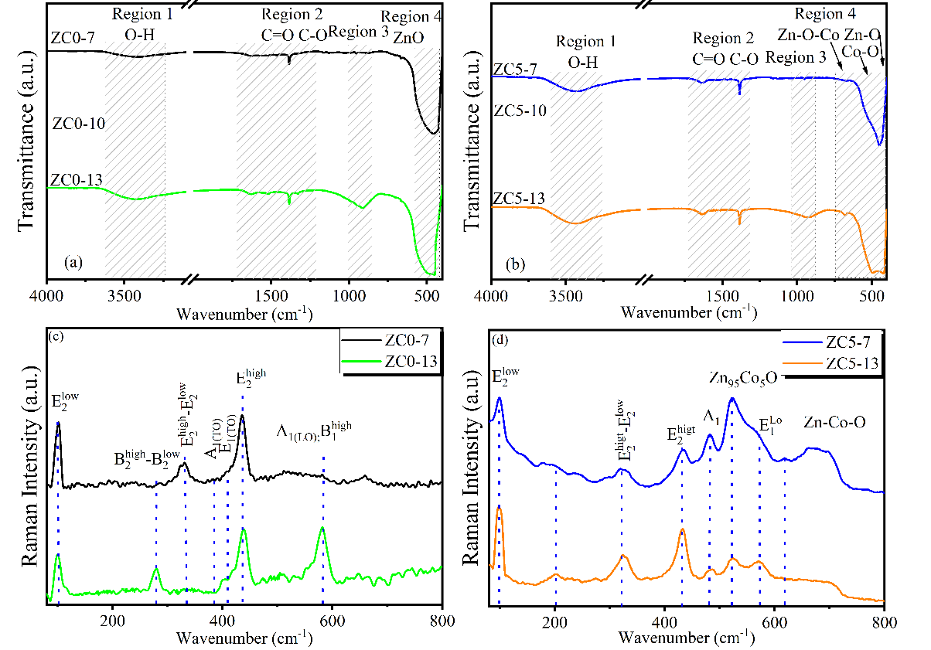
Figure 1. (a and b) FTIR spectra of the Zn_{1-x}Co_{x}O system (x = 0.00 and 0.05) sintered at 500°C and (c and d) Raman spreading spectra from samples ZC5-7 and ZC5-13 varying pH (7 and 13).
Figure 1 (c and d) shows the Raman spectra of the samples. As observed, the samples show the main active vibrational modes of the wurtzite structure of ZnO. As shown in Figure 1b, two modes observed at 98 and 433 cm⁻¹ are assigned to $E_{2}^{low}$ and $E_{2}^{high}$ for standard ZnO. The other expected modes for ZnO are ${2E}_{2}^{low}$, $E_{2}^{high}−E_{2}^{low}$ and $A_{1}\left(LO\right)$. They show strong changes as a function of pH variation. The peak detected at 483 cm⁻¹, corresponds to the second-order phonon mode, and exhibits A1 symmetry. The new Raman peak at 524 cm⁻¹ in Co-doped ZnO nanocrystals suggests that Co can affect local polarizability by shifting distribution, resulting in a Co-related vibrational mode, which is linked to donor defects [1]. Around 710 cm⁻¹, it may be associated with disordered local vibrational modes of –Co–O–Zn– in ZnO. The effect of pH can be seen by the relative intensities A₁(LO) /$E_{2}^{high}$. This indicates that the increase in pH can generate symmetry breaking, activating silent modes (VILLAFUERTE et al., 2022).

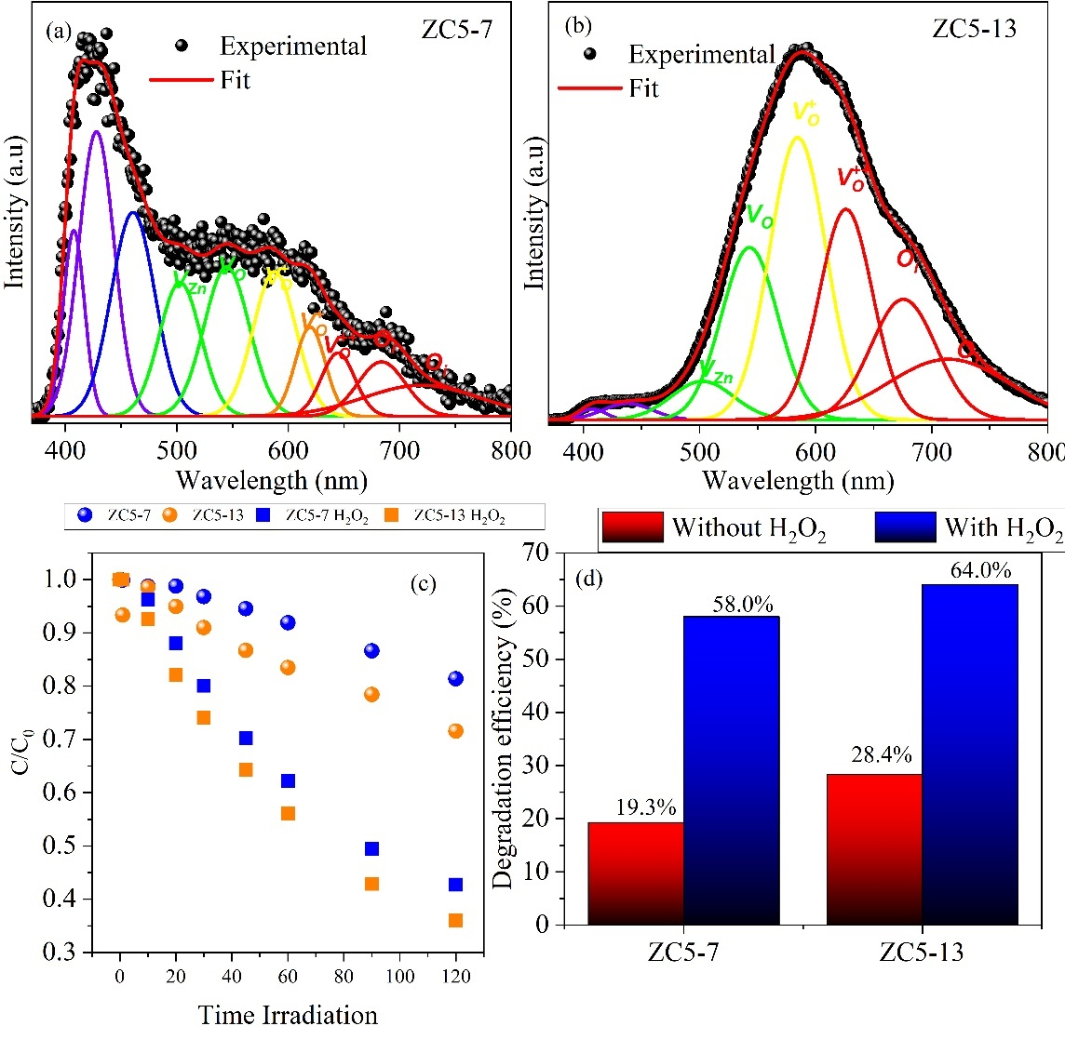
Figure 2. PL spectra of doped ZnO nanostructures synthesized at 500°C, varying pH values (7 and 13). (a and b). Photocatalytic performance of samples ZC5-7 and ZC5-13 under different pH conditions.

Figure 2 a show the photoluminescence spectra (PL) for the Zn_{1-x}Co_{x}O system with pH 7 and 13. The first around 370 to 420 corresponds to excitonic recombination (electron-hole pair) and the second in the range from 425 to 750 is attributed to intrinsic defects (SOARES et al., 2022). In sample ZC5-13 the peak around 370 shows low intensity in relation to the visible region. The low intensity of the ultraviolet peak occurs due to the high intensity of the visible emission, which is due to the high concentration of defects in the synthesized material.
The C/C_{o} ratio was slightly affected in systems performed with ZC5-7, ZC5-13 samples, as demonstrated in Figure 2c. A comparison of the degradation efficiency for materials synthesized at different pH values is shown in Figure 2d. In tests using ZC5-7 and ZC5-13 at a concentration of 0.25 g.L⁻¹, a degradation rate of 19.30 and 28.43%, respectively, was observed. In accordance with these results ZC5-13 demonstrated a greater ability to remove the PPI drug. As seen in Figure 2b, there is a predominance of oxygen vacancies in ZC5-13. This suggests that the better performance in the photocatalytic activity of ZC5-13 in relation to ZC5-7 is related to the existence of oxygen vacancies in greater quantity on the surface of the nanorods of the sample ZC5-13.
Conclusions
The FTIR spectra confirm the formation of the wurtzite structure in ZnO nanoparticles. Detachments in vibrational modes caused by pH and doping were confirmed by Raman spectroscopy measurements. The results showed the emergence of additional modes that are associated with the insertion of the dopant in the hexagonal structure of ZnO. These additional modes vary due to the influence of pH. Photoluminescence studies revealed the influence of pH on structural defects watered by pH variation in Cobalt-doped ZnO nanostructures. The photocatalytic study suggests that the existence of structural defects such as oxygen vacancy plays a positive role in the photocatalytic activity of Co-doped ZnO nanorods.
References

CASTRO-LOPES, S. et al. Influence of pH on the structural and magnetic properties of Fe-doped ZnO nanoparticles synthesized by sol gel method. Solid State Sciences, v. 109, p. 106438, nov. 2020.
PEÑA-GARCIA, R. et al. Unusual thermal dependence of saturation magnetization in zinc oxide nanoparticles doped with transition metals obtained by sol gel method. Ceramics International, v. 45, n. 1, p. 918–929, jan. 2019.
PUNIA, K. et al. Defects and oxygen vacancies tailored structural, optical, photoluminescence and magnetic properties of Li doped ZnO nanohexagons. Ceramics International, v. 46, n. 8, p. 12296–12317, jun. 2020.
PUNIA, K. et al. A comprehensive study on the impact of Gd substitution on structural, optical and magnetic properties of ZnO nanocrystals. Journal of Alloys and Compounds, v. 868, p. 159142, jul. 2021.
SOARES, A. S. et al. The role of pH on the vibrational, optical and electronic properties of the Zn Fe O compound synthesized via sol gel method. Solid State Sciences, v. 128, p. 106880, jun. 2022.
VILLAFUERTE, J. et al. Modulating the growth of chemically deposited ZnO nanowires and the formation of nitrogen- and hydrogen-related defects using pH adjustment. Nanoscale Advances, v. 4, n. 7, p. 1793–1807, 2022.

